

Data Warehousing & Business Intelligent

(IT)

3rd Year, 1st Semester

**Assignment 2 - part 2**

Submitted to

Sri Lanka Institute of Information Technology

Bachelor of Science Special Honors Degree in Data Science

IT17167710

D.M.J.Prathapa

Weekday Batch

Designing the Dashboard

To Build a suitable dashboard in Power BI. I have Used the data from **IT17167710_DataWareHouse.**

Dashboard link<https://app.powerbi.com/groups/me/dashboards/b02cb5c8-7974-4472-a52e-daaaa8fa7619?ctid=44e3cf94-19c9-4e32-96c3-14f5bf01391a>

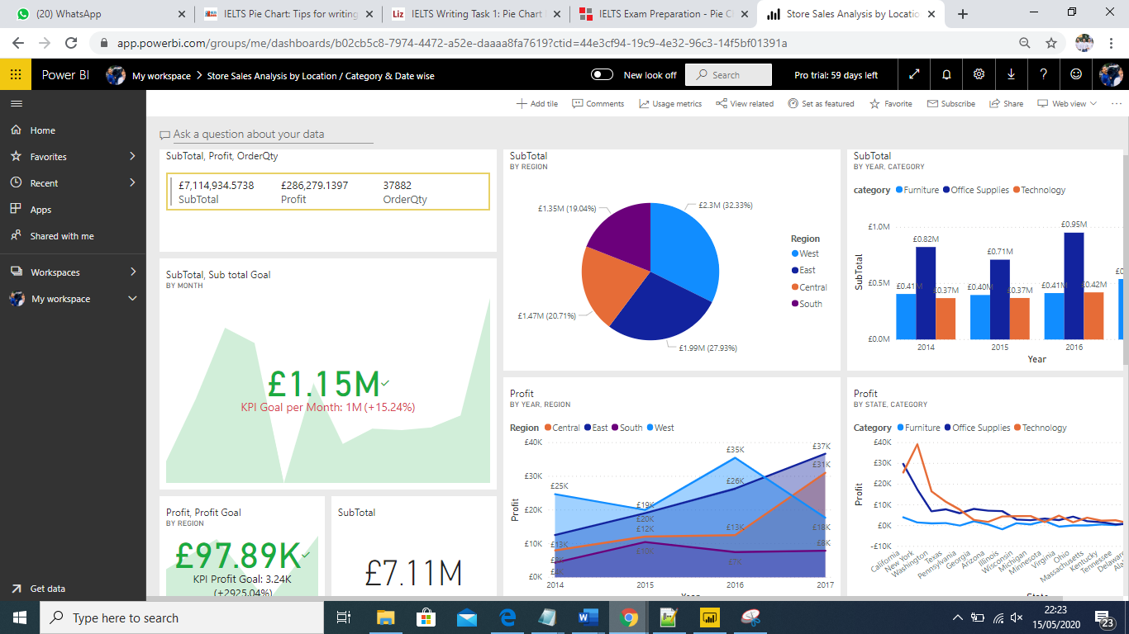

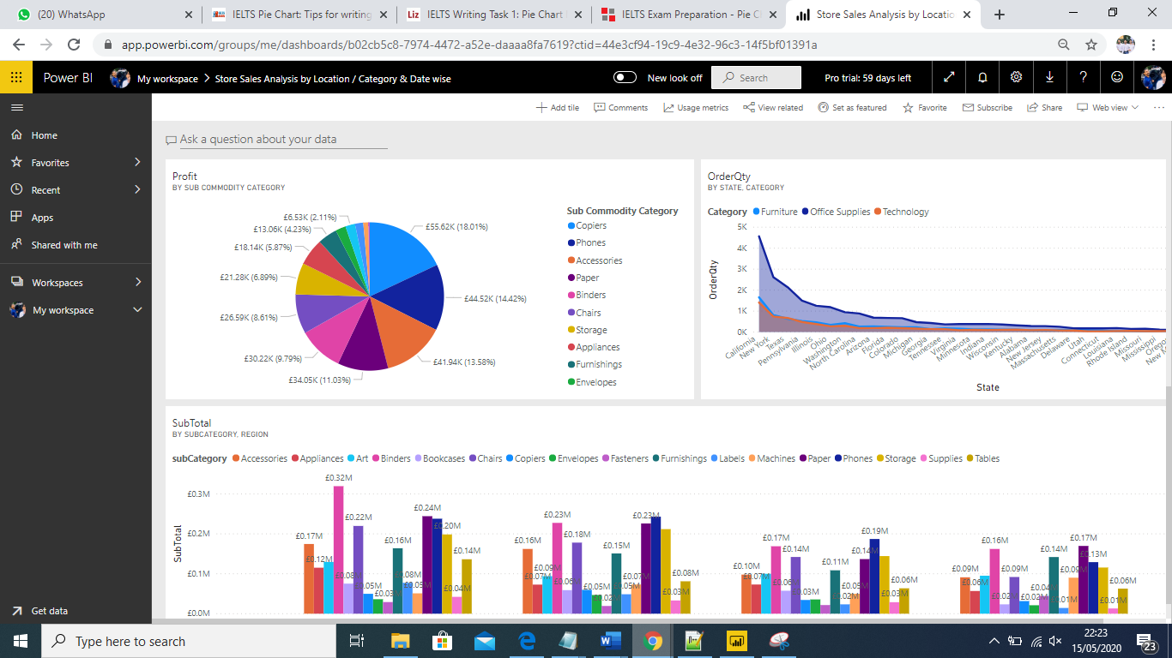

**Audience**

This is a Business referred to as "Super Store”. This is a US business that has been unfolded via mainly four regions. They are East, West, North, and Southern. The analysis is ordinarily necessary to **the Top-Level Managers, and the Promote Sales Representatives**.

|  |
| --- |
|  |

**Story**

The analysis has been mainly performed in three ways. They are Location-wise, product and product Category wise and Date wise. According to the analysis end result, Top-level Managers and Owners can enlarge the extent of the product in the states where the product demand is high and minimize the extent of the product in areas where the product demand is low. Furthermore, some products are high in availability in some seasons. So that the Sales Representative can promote the most wished product in these seasons in order to improve the Business.

**Amount of Sales By location and category wise**

The First analyses have been accomplished in Location-wise sales details. The Profit, Sub Total, and Commodity Quantity have been used as the measurements. Furthermore, the analysis has been completed in Region-wise, State wise and City wise. According to this analysis maximum profit and the maximum variety of portions have been promoted and sold at West Region in California state. Moreover, the Top-Level Managers and the Owner can decide the deliverable places according to the wide variety of sales in particular regions. And the Sales Representatives have to promote more products in the places where the product is demand. If the Sales Representative promotes the products more, in states and areas where the product has a greater demand it is effortless to improve the business.

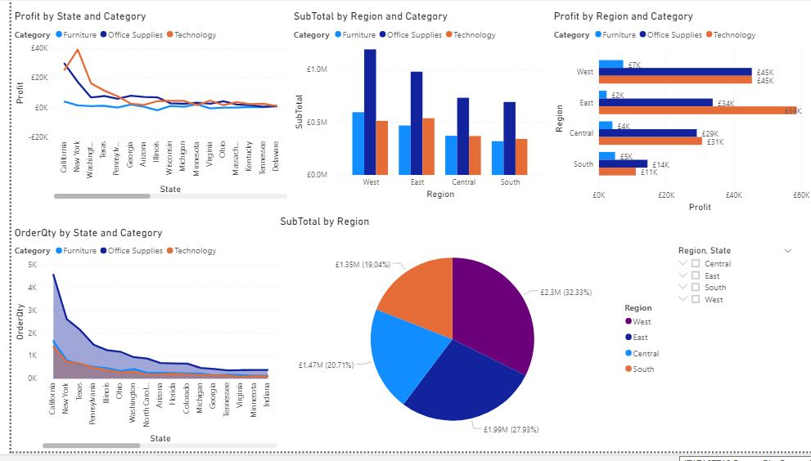

**Sales analysis by Date / category and Location wise**

The 2nd analysis is primarily based on Date wise. Four years of dates have been used for this analysis. They are 2014,2015,2016 and 2017 in years. The measurements that have used in this analysis are Profit, Sub Total, and Order Quantity. According to the analysis, greater income has been carried out in the year 2017. The output can sincerely get as which quarter and month the products have maximumly offered and can promote the applicable product and get a high income throughout that month. Furthermore, the Owner is responsible to make a greater volume of that product in that duration. However, if the Sales Representative promotes the product in this season, it is simple to enhance the Business.

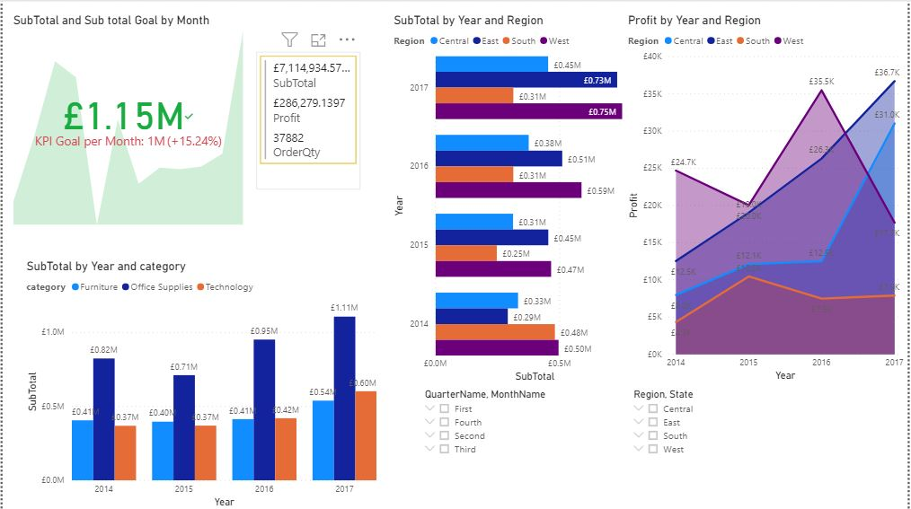

**Sales analysis by Subcategory and Location wise**

The 3rd evaluation has been executed in the Commodity, Commodity category and Sub Commodity Category wise and the measures which have been using are the Profit, Order quantity, and Sub Total. Three categories have been used to analyse. They are Office Suppliers, Technologies, and Furniture. Furthermore, Office Suppliers are the major product that has been promoted most. Moreover, Copiers subcategory have been selling as Office Suppliers as the end result.

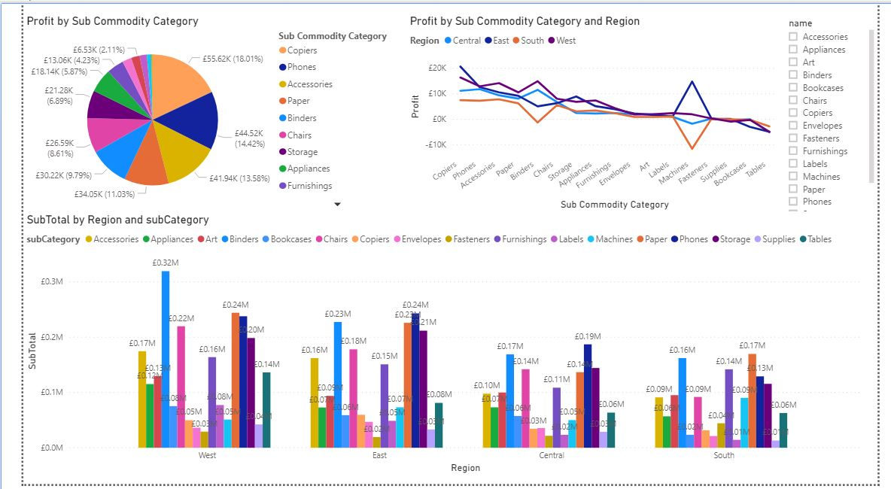

**Main Graphs**

**Pie chart – Subtotal by Region wise**

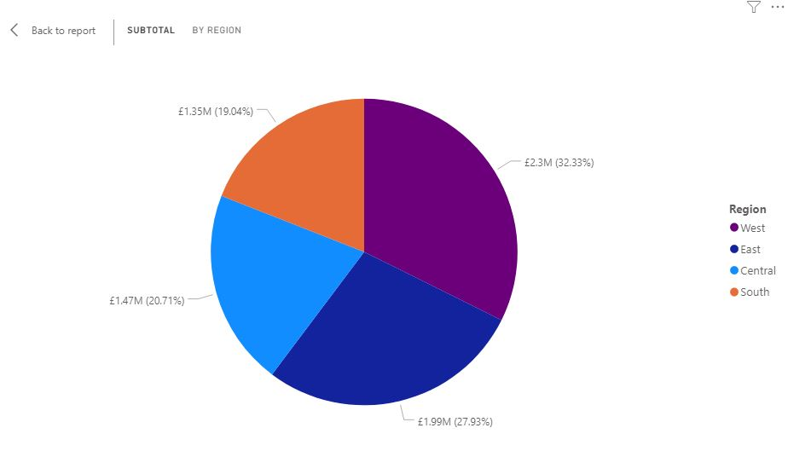

The above displayed pie chart is clear illustration of sales subtotal Occurred in different regions in US country. Overall, it is ostensible that the maximum sub total sales go to west region while the minimum subtotal goes to south.

**Clustered Column Chart – Subtotal by Region and category wise**

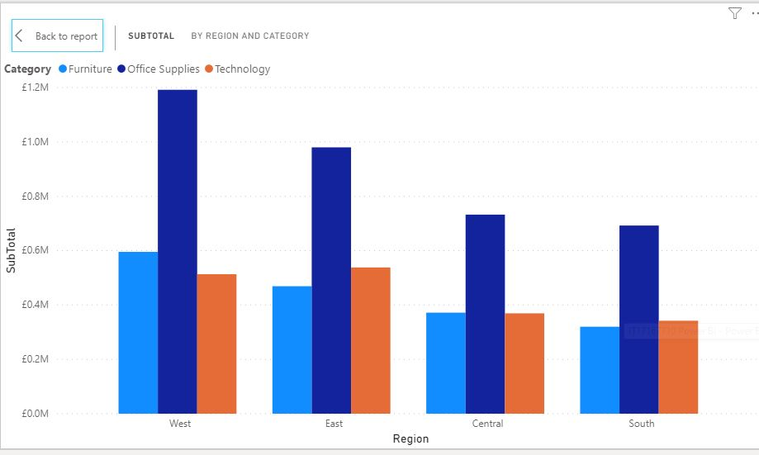

The bar chart compares three main commodity categories (Furniture, Office Suppliers, Technology) in US in terms of summation of their sales in East, west, central and south regions. Office Suppliers are the major product that has been promoted and sold most in every Region. Moreover, Copiers subcategory have been selling as Office Suppliers as the end result.

**Pie chart – Profit by Sub commodity Category wise**

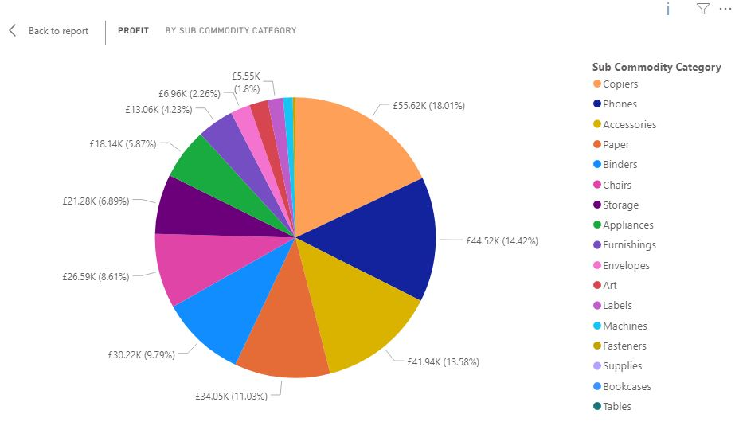

According to the above pie the maximum profit came from Copiers subcategory while the minimum goes to tables subcategory.

**Clustered Column Chart – Subtotal by Date and category wise**

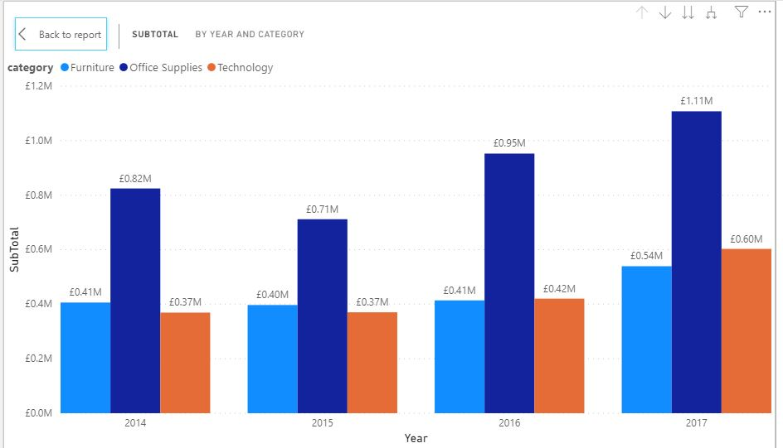

The above bar chart compares three main commodity categories (Furniture, Office Suppliers, Technology) in US in terms of SUM of their sales subtotal in four years, 2014,2015,2016 and 2017.

Overall the sum of each subtotal for each of the three-category changed significantly from 2014 – 2017. While the figures for Furniture, Office Suppliers and also Technology increased.

In 2014, the subtotal of office suppliers was 0.82 million, but this rose to 1.11 million in 2017. And technology category commodities rose to 0.37 million to 0.60 million.

**4 - KPIs**

A Key Performance Indicator is a measurable value that demonstrates how effectively a company is achieving key business objectives

So, as a KPI I have introduced the subtotal and subtotal goal by month.

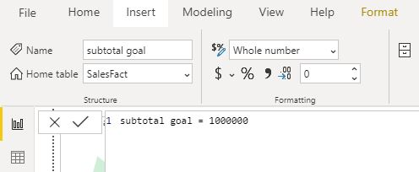

**For the target goal I have created a new measure called subtotal goal and set the measure value for 100000.**

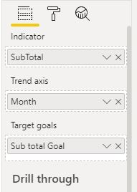

* Drag and drop KPI Indicators visual to design panel
* Then I have set indicator value field to subtotal
* And Set Trend axis field to month
* After that I have included Target value field to subtotal goal measure that I have created previously.

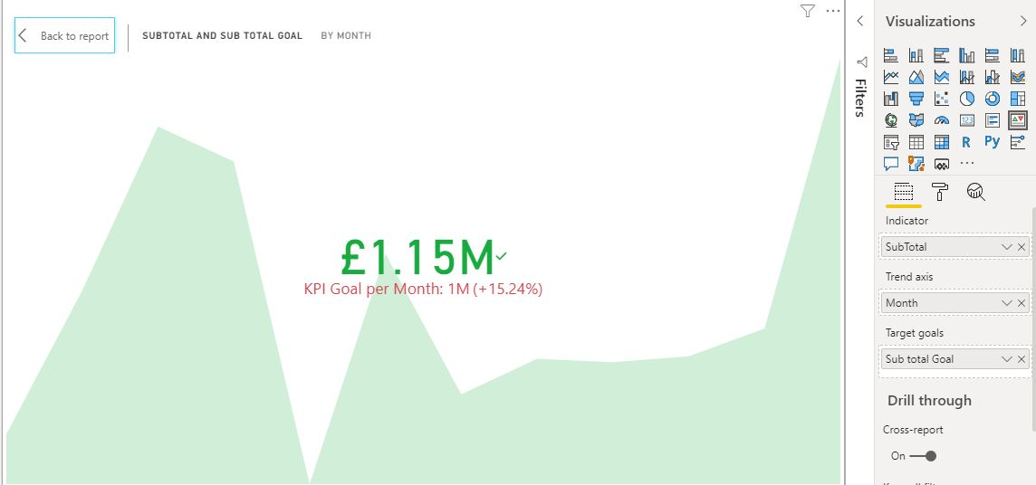

The intention was set to acquire 1 million Sub Total monthly. However, the monthly remaining end result of the Sub Total was 1.5 million. So that it is crystal clear that Business is a success.

**Reason for selecting display types**

Mainly I have used 4 types of Graphs.

* Pie chart

Pie charts are simple and easy-to-understand picture which means be visually simpler than other types of graphs, it will help to. Summarize a large data set in visual form.



* Line charts

The reason for choosing Line graphs because it is very useful that they show data variables and trends very clearly and it will help to make predictions about the results of data not yet recorded.

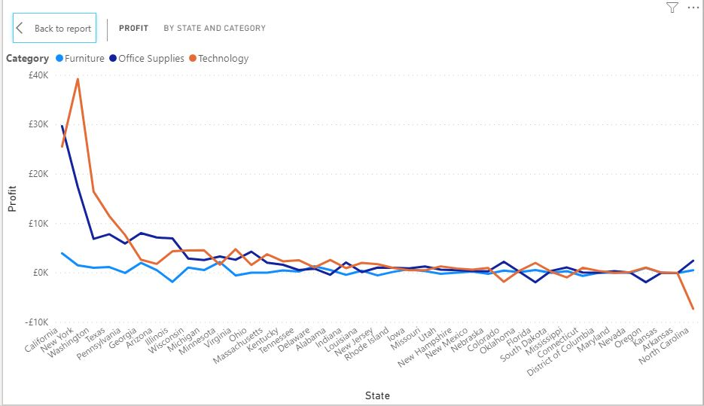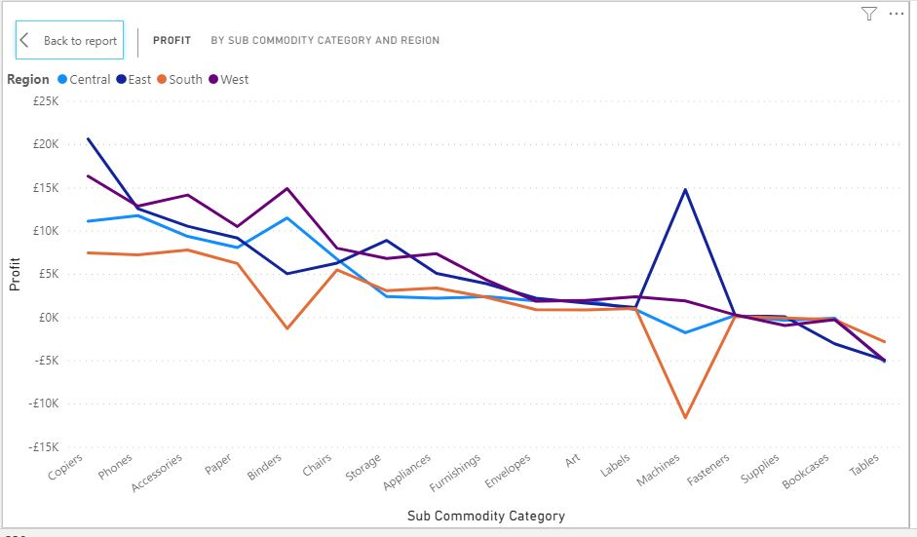

* Area charts

Area graphs are very similar to line graphs. They can be used to track changes over time for one or more groups.

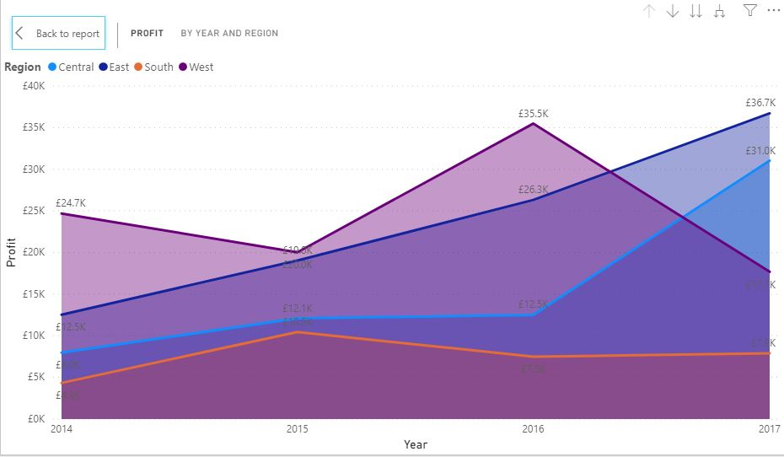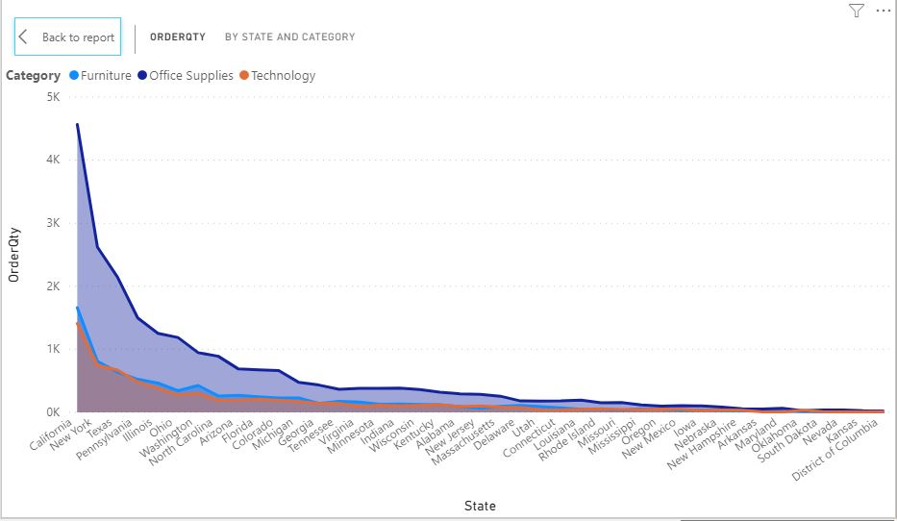

* Clustered Column Chart:

Reason for a selecting Clustered Column Chart graph is useful for looking at a set of data and making comparisons.





Alert

For the alert I have created another KPI based on profit and profit goal by region.

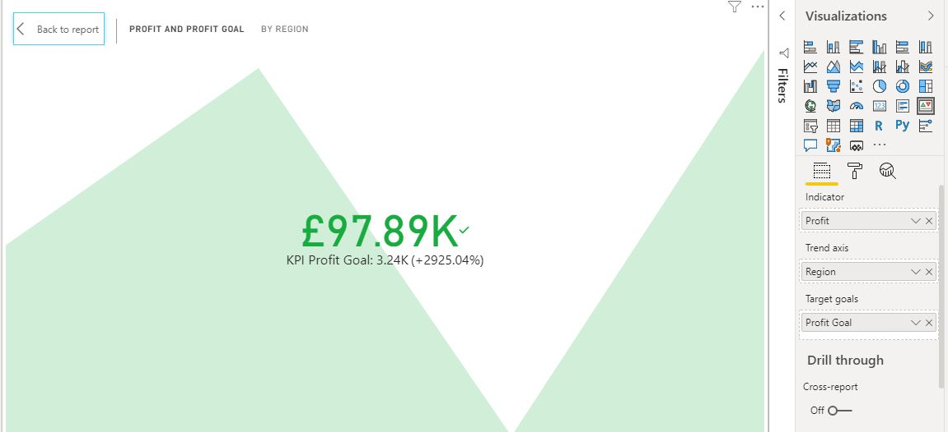

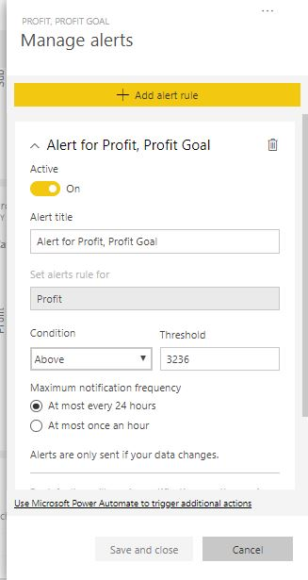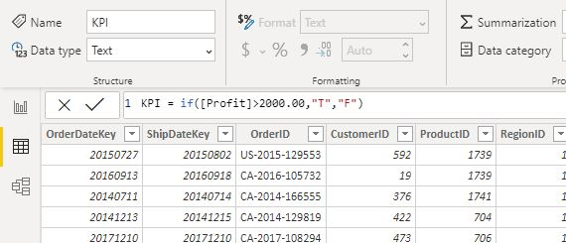

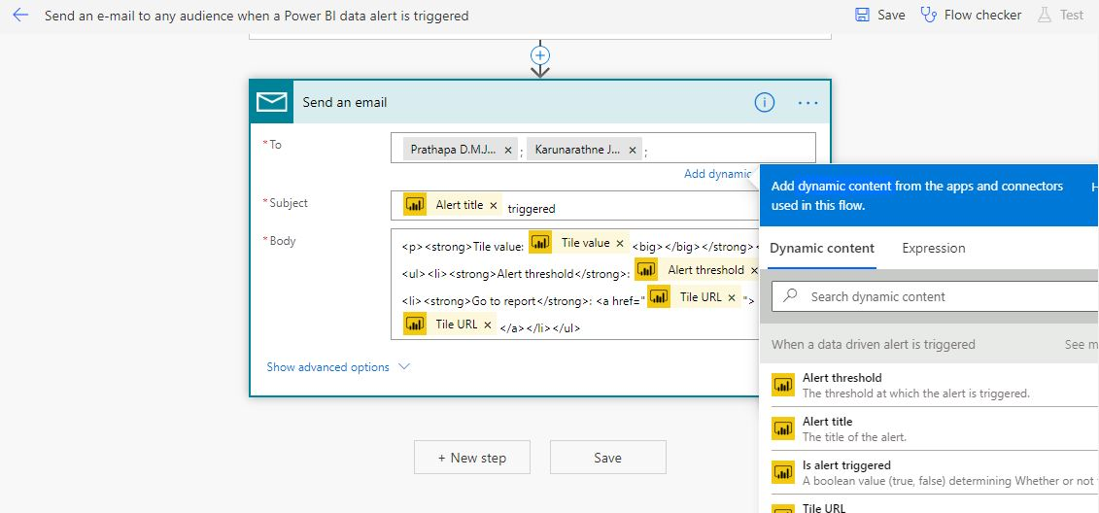

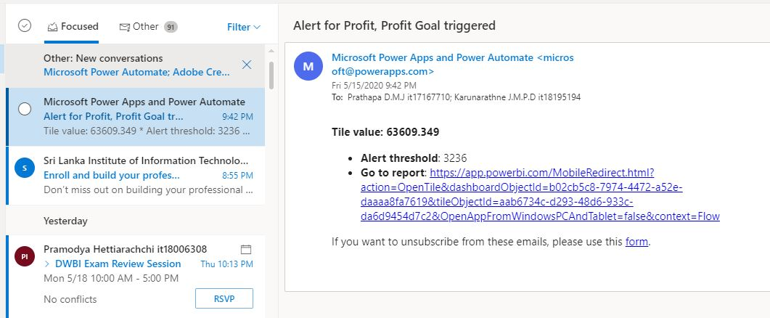

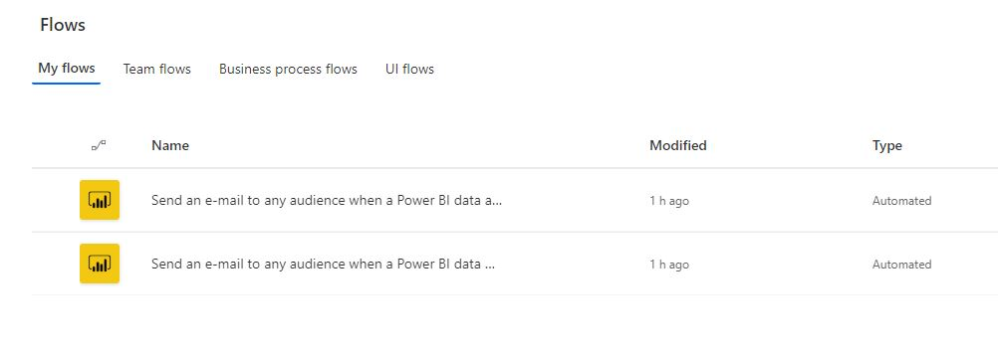

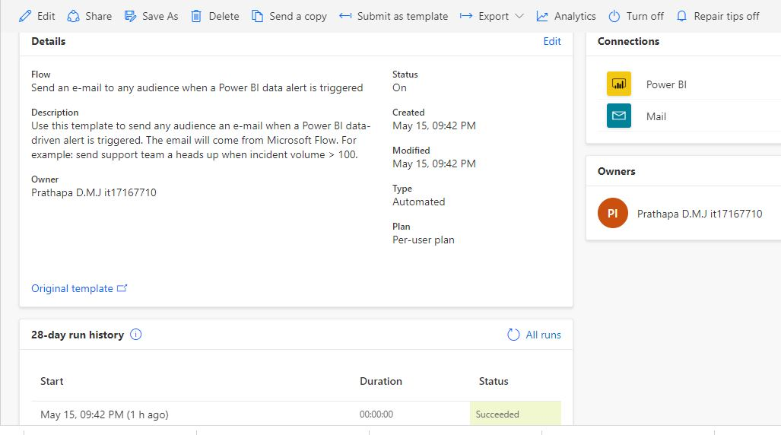

The audience, top-level Managers, sometime business owners, promote sales representative who are drawn to this report- outcome may be entirely based on the value of selected business activity, reliable data and how those are evaluated by using tools of data science to forecast future actives of ongoing business.This report is based on a huge chain of Business named “Super Store “in USA that has been unfolded via four main regions of the country as East, West, North, and Southern. This analysis is based on above mentioned business and its activities during past selected years including data obtained accurately from trusted source which could be vouched of their confidentially.

**References**

<https://www.tutorialgateway.org/drill-through-reports-in-ssrs/>

<https://docs.microsoft.com/en-us/sql/reporting-services/report-design/drillthrough-reports-report-builder-and-ssrs?view=sql-server-ver15>

<https://docs.microsoft.com/en-us/sql/reporting-services/report-design/drilldown-action-report-builder-and-ssrs?view=sql-server-ver15>

<https://www.mssqltips.com/sqlservertutorial/9082/sql-server-reporting-services-ssrs-2017-parameters/>